**ASSIGNMENT 11.1**

**DATA SET DESCRIPTION Column 1: District ID I4N 1M1 varchar**

**Column 2: Distributor name shell varchar**

**Column 3: Buy rate (million) $957.70 varchar**

**Column 4: Sell rate(million) $5779.92 varchar**

**Column 5: volume IN(million cubic litre) 933, int**

**Column 6: volume OUT(million cubic litre) 843, int**

**Column 7: Year 1624 int**

**1. What is the total amount of petrol in volume sold by every distributor?**

**2. Which are the top 10 distributors ID's for selling petrol? Also display the amount of petrol sold in volume.**

**3. List 10 years where consumption of petrol is more with the distributer id who sold it.**

**4. Find the distributer name who sold petrol in least amount.**

**ANS 1)**

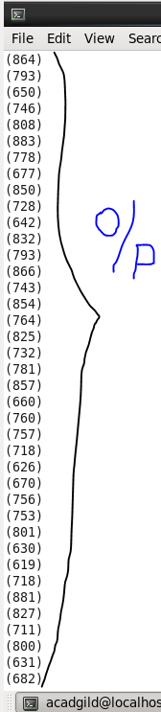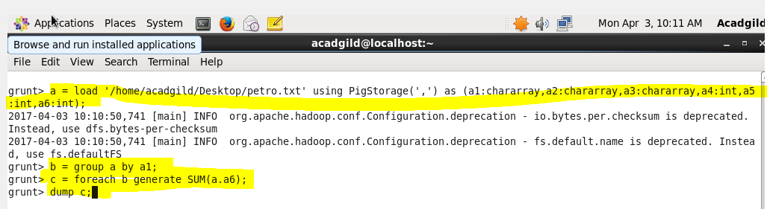

**ANS 2)**

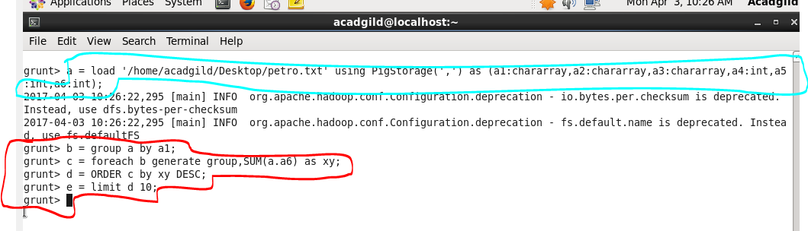

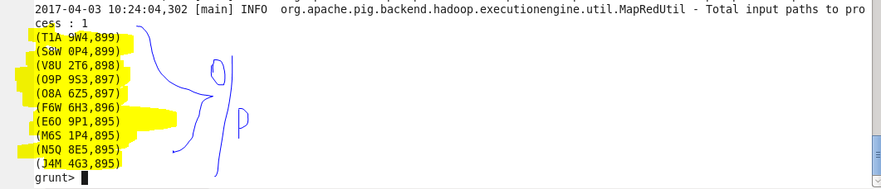

**ANS3)**

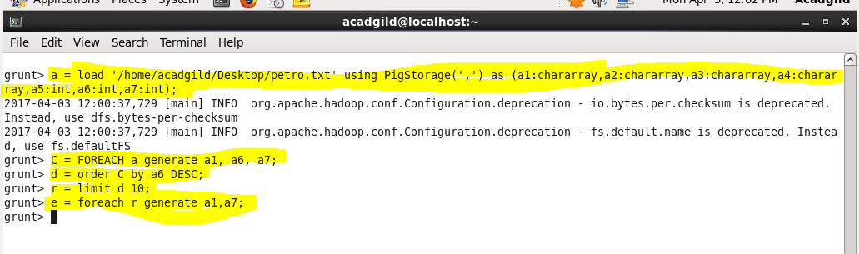

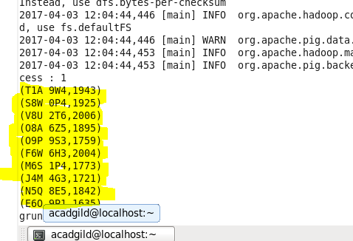

**ANS4)**

